Chernobyl
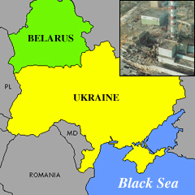.
In the year 1986 there was a terrible explosion. The explosion was at a nuclear power plant in the another country called Ukraine. The radiation caused a lot of damage. It contaminated the soil and other things. People lived in the area when the explosion happened. Twenty years later those people are still suffering. Effects from the explosion will go on for a long time.
Over two million people still live in the contaminated areas. Only 56 people died from the explosion but many other problems have been caused because of it. Some types of cancer are more than 200 times above world average. Many children have cancer now and birth defects have doubled since the accident.
Some people in the United States are worried about the children living there. One group has been trying to raise money. They are called the Chernobyl Children's Project. They want to bring children from the Ukraine to the U.S. each summer.
A spokesperson for the group says that radiation is the highest in the summertime so it is a good time to get the children out of the country. They want to help the children get away for a little while. The Project wants them to be safe from radiation.
It costs $1,500 to bring each child to the United States for six weeks. The group raised enough money to bring 28 children to the United States. They children were able to do lots of fun things. They enjoyed clean air, healthy food, and plenty of outdoor fun.
One little nine year-old girl who got to come to the United States said that she likes America.
A spokesperson for the Project said that the children that come to America during the summer miss less school when they return home.

