Teen Drinking
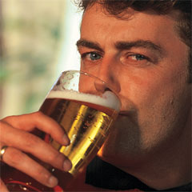
Some kids start to drink alcohol at a young age. They think it is part of becoming an adult. They also think drinking is not that bad because so many people do it. They feel it is not as bad as taking drugs. It is easy for kids to get liquor by using fake identification.
Parents may start to notice a change in their child’s behavior if the child starts drinking. Kids who drink sometimes stop doing things they normally liked to do. They may keep telephone calls and meetings a secret and not want anybody to touch their things. They act moody and do not have the same eating and sleeping habits.
Parents need to stay involved in their kids’ lives. They should talk to their children about their problems to be aware of any changes.
Parents can be the best protection. Children who get a lot of love can feel good about themselves. It helps them resist doing bad things even when other kids are doing them. Parents can also help set a good example by not drinking and driving. They can have firm rules in the home that everyone follows.
Give the children good ideas on how to say "no" to drinking, even when they are at a party. Try not to overreact or panic if the child tries alcohol. How you handle it can affect their attitude. It may be helpful to talk to other parents about setting up curfews and rules about parties or other events.

